**QR Code Pursuit!**

**Integrating Technology with**

**Health Related Fitness Components**

**Patty Kestell**

**2013 NASPE National Elementary Physical Education TOY**

***Thorson Elementary School- Cedarburg, WI***

[**pkestell@cedarburg.k12.wi.us**](mailto:pkestell@cedarburg.k12.wi.us)

**@pk_lv2teachpe**

**Health Related Fitness QR Code Activities**

# Health Related Fitness Stations

### Differentiated Physical Activities

### Create QR Codes for several stations that include 3 differentiated levels of activities.

### Link YouTube videos to the QR Codes to show the different skills.

###### **Curl ups**- Curl ups, Medicine Ball Crunches, Pilates 100’s

###### **Pushups**- Hockey, Shoulder Taps, Knee or Standard

###### **Squats/Lunges**- Forward Lunges, Squats, Side Lunges

* **Target Heart Rate Chart**

**Muscle Clue**

* **Muscle Clue is a cooperative challenge that helps students recognize muscle groups**
* **Muscle Clue helps students understand how the muscles connect to the health related fitness components.**

**Health Related Fitness Concepts Worksheet/Homework**

* **Make a QR Code for each health related fitness component**
* **Have students use the information to help answer the worksheet**

**Health/Physical Activity Article Web Link**

* **During a center time in the classroom or at home, have students read an article that is embedded in a QR Code.**

**Health Related Fitness Stations**

**Curlup QR Codes:**

** **



**Curl Ups Medicine Ball Crunches Pilates 100’s**

**Pushup QR Codes:**

  ** **

**Hockey Push Ups Shoulder Tap Push Ups Knee/Regular Push Ups**

**Lunges/Squats QR Codes:**



**Forward Lunge Squats Side Lunges**

**Physical Education**

**Health Related Fitness Components**

**Cardiovascular Endurance**

* The ability to move the body at a moderate to vigorous pace for an extended period of time
* The heart and lungs work together to create cardiovascular endurance

**Muscular Strength**

* The maximum amount of force that a muscle can exert against resistance in a single effort
* Lifting or carrying heavy objects for a short distance or a few reps
* Holding or supporting your own body weight

**Muscular Endurance**

* The ability of a muscle to do repeated work against resistance over a period of time
* Lifting a weight for many repetitions
* Holding or supporting your own body weight for a long time

**Flexibility**

* The ability to move muscles easily throughout their range of motion
* Allows people to move more freely and reduces the risk for injury

**Body Mass Index**

* BMI is a number that is calculated according to a person's height and weight.
* Age and gender are also factored into children's and teenager's BMI
* BMI information is shared on the Fitnessgram to help parents /students know if their BMI is within the healthy fitness zone or not

**C:\Users\pkestell\AppData\Local\Microsoft\Windows\Temporary Internet Files\Content.IE5\SETQOPVS\MC900355945[1].wmfC:\Users\pkestell\AppData\Local\Microsoft\Windows\Temporary Internet Files\Content.IE5\NJCL2WE8\MC900053962[1].wmf**

**Muscle Clue**

**Team _______________________________**

**Color (Circle) Yellow Purple Green Red Blue Orange**

An unidentified staff member completed a great workout throughout school and worked out almost all of the muscle groups, but forgot one. Can you figure out who the staff member was, what room they missed and what muscle group they forgot to work out?!?

|  |  |  |  |  |  |
| --- | --- | --- | --- | --- | --- |
| **Staff Member** | **SM** | **Room** | **R** | **Muscle** | **M** |
| Custodian |  | Art Room |  | Bicep |  |
| Art Teacher |  | Music Room |  | Tricep |  |
| Principal |  | Office |  | Quadricep |  |
| PE Teacher |  | Classroom |  | Hamstring |  |
| Secretary |  | IMC |  | Pecs |  |
| Music Teacher |  | Computer Lab |  | Abdominal |  |
|  |  | Lunch Room |  |  |  |
|  |  | Guidance Office |  |  |  |
|  |  | Gym |  |  |  |

* Your team will be given a certain color for Muscle Clue.
* One team member at a time is the “Clue” detective, while the rest of the team runs one lap around the gym, connected by a hula hoop.
* When your “Clue” detective moves to a new spot, open up the QR Code that matches your team’s color.
* When you receive a clue, mark it down on your paper, and then do the physical activity that is listed.
* Do not open another team’s QR Code since it will negatively affect your investigation! Each team will have a different solution.

Staff Member? _______________________________________________

Room? ______________________________________________________

Muscle? _____________________________________________________

**C:\Users\pkestell\AppData\Local\Microsoft\Windows\Temporary Internet Files\Content.IE5\NJCL2WE8\MC900053962[1].wmfC:\Users\pkestell\AppData\Local\Microsoft\Windows\Temporary Internet Files\Content.IE5\SETQOPVS\MC900355945[1].wmfMuscle Clue**

**Teacher Resource Sheet**

**Physical Education Standards**

Standards 2, 3, 4

**Muscle Clue Equipment**

6 cones 25 stretch bands/weighted objects for bicep curls, etc

6 hula hoops 1 score sheet, clip board, and pencil per team

6 QR codes/clues/activities per cone Muscle Clue solution

**Muscle Clue Directions**

* Form 6 teams and divide students so that there are about 4 or 5 per team.
* Assign each team a color.
* Hand out Muscle Clue Score Sheet and one jump rope per team.
* Each team should start at a cone.
* Use the iPad or smartphone to access the QR Code. When the code is opened, a clue will appear. Check off the appropriate boxes on the scoresheet. Leave iPad at station.
* Send one teammate ahead to begin solving next clue, while remaining teammates run one lap around gym before moving on to the next clue. They should stay connected with the hula hoop as a team to get to the next clue. Complete the station exercises before moving on to the next clue.
* Students should check in with you when they think they have the answer. Teams that have solved Muscle Clue should stretch out while waiting for other groups to finish.

**Sample Muscle Clues and Activities**

**Green-**

It was not the PE teacher! The PE teacher did curl-ups in the art room. Curl-ups

The custodian did bicep curls with the lunch trays in the lunchroom. ☺ Bicep Curls

It wasn’t the school secretary. She did 25 pushups while filing papers in the office. Push ups

The missing workout wasn’t in the gym. Students were active in a PE class. Jumping Jacks

The art teacher and music did some wall sits in the music room while planning a lesson. Wall sits

The IMC, Computer Lab, and Guidance offices were all busy with students. Crab Walk

**Purple- Yellow- Red- Blue- Orange-**

**Muscle Clue Solutions**

|  |  |  |  |  |  |
| --- | --- | --- | --- | --- | --- |
| **Yellow** | **Purple** | **Green** | **Red** | **Blue** | **Orange** |
| Custodian | Art Teacher | Principal | PE Teacher | Music Teacher | Secretary |
| Gym | Lunchroom | Classroom | Office | IMC | Computer Lab |
| Bicep | Quadricep | Hamstrings | Abdominals | Tricep | Pecs |

**Muscle Clue QR Codes- Green**

** Clue #1 Clue #2 Clue #3**

**Clue #4 Clue #5 Clue #6**



**Muscle Clue Health Related Fitness Component Questions**

* What component/s of health related fitness were emphasized and worked on in this Muscle Clue activity?
* Which activity/activities targeted cardiovascular endurance?
* What activity/activities targeted muscular strength and muscular endurance?
* At the end of our activity we stretched our muscles to cool down. What health related fitness component were we working on? Name one stretch you did to work on your flexibility.

**Health Related Fitness Components**

**Scan these QR Codes to learn more about the Health Related Fitness Components!**

***Use this information to help answer questions on the Physical Education***

***Health Related Fitness Component Worksheet.***



**Cardiovascular/Respiratory Endurance**



**Muscular Strength**



**Muscular Endurance**



**Flexibility**



**Body Mass Index**

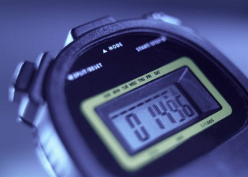**Name __________________________**

**Class ___________________________**

**Physical Education Health Related Fitness Components**

1. The maximum amount of force that a muscle can exert against resistance in a single effort is ________________ _________________.
2. _________________ __________________ is the ability to move the body at a moderate to vigorous pace for an extended period of time and helps the heart and lungs get stronger.
3. ________ is a number that is calculated according to a person's height and weight. Age and gender are also factored into children's and teenager's BMI.
4. Flexibility is the ability to move muscles easily throughout their _______________ of ________________.
5. To develop _______________ ______________ a muscle must be able to perform against resistance over a longer period of time.
6. Running, swimming, jump roping, and bicycling at a moderate to ______________ pace for an extended period of time can help you develop your ________________ endurance.
7. What is one activity that I could do to develop muscular endurance in my arms? ___________________ Legs? _____________________
8. 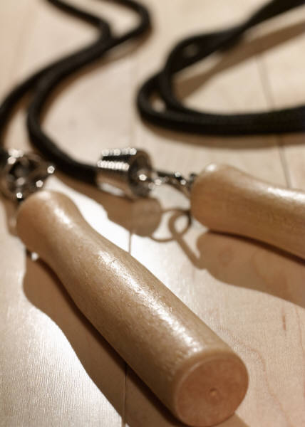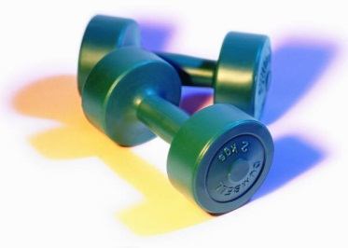C:\Users\pkestell\AppData\Local\Microsoft\Windows\Temporary Internet Files\Content.IE5\SETQOPVS\MC900212431[1].wmfWhy is it important to have good flexibility? It allows people to move more freely and ________________ the _________ for ______________.

**PE Newsletter or Homework Idea**

***Physical Activity/Health Article Web Link***

* During a center time in the classroom or as a homework assignment, have students read this *Kids Health* article.
* Consider using this idea in your next PE Newsletter article.
* Check out the QR code that has this web link embedded in the code.

<http://kidshealth.org/kid/stay_healthy/fit/work_it_out.html>

**Developing QR Codes**

* Choose an existing web link or YouTube video (or create your own)
* If you created your own YouTube clip, find clip in “uploaded” area of your YouTube profile
* Copy URL address
* Go to QR code app or website: <http://www.qrstuff.com>
* Enter URL in appropriate space, choose your color, and download QR code
* QR code is created. Save image. On an iPad, the QR code is saved in your camera roll/photos.
* When ready to use code, insert into your document.

**Developing QR Codes, cont’d**

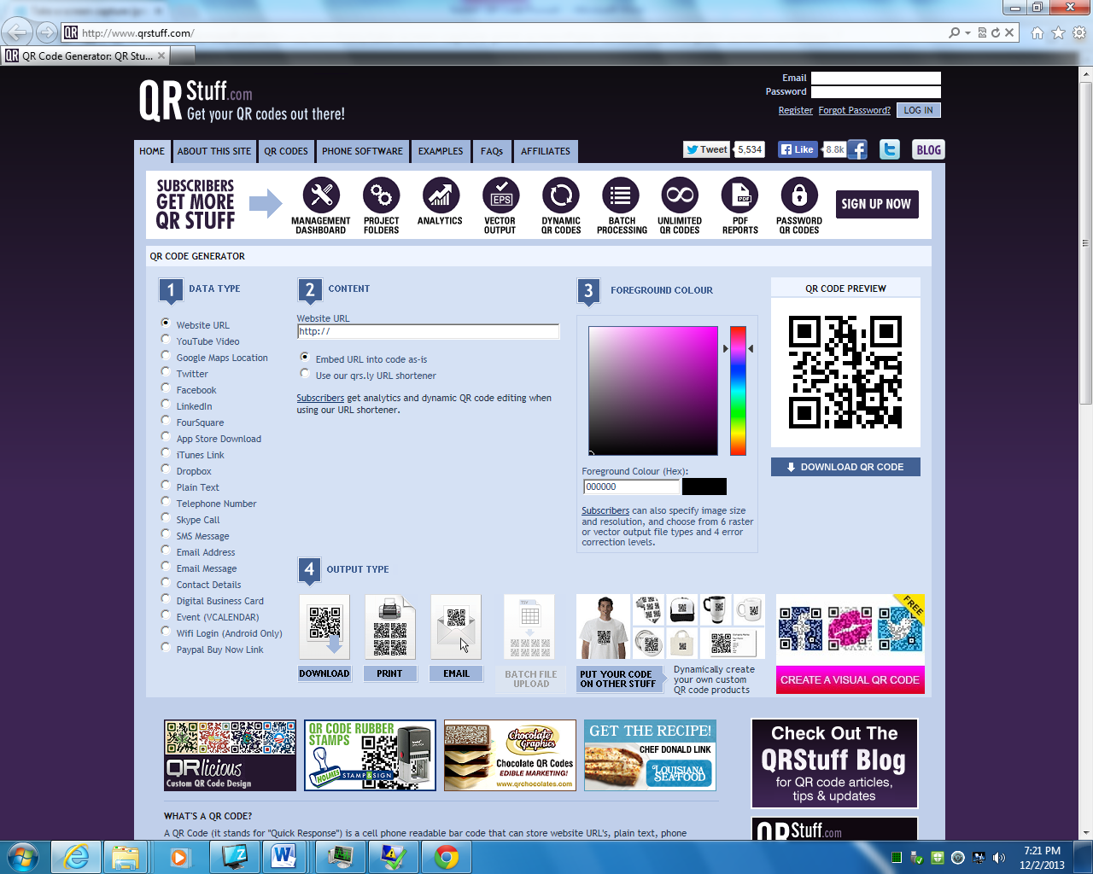<http://www.qrstuff.com>